

Mini Project Report - 09

Master of Computer Application
Semester – I

Sub: Front-End Frameworks and Technologies

Topic: Dynamic To-Do list Application

By
Name: YUVRAJ PAARTH
Reg no: PROV/ASAC/MCA/7/26/083

Faculty Name: VEERA RAGHAV K

Faculty Signature: _______________

Department of Computer Application
Alliance University
Chandapura - Anekal Main Road, Anekal
Bengaluru - 562 106
August 2026

INDEX

sl no | Topics | Pg no
1 | Introduction | 2
2 | Input | 3-7
3 | Output | 8
4 | Conclusion | 9

INTRODUCTION
The To-Do List application is a simple task management tool built using HTML, CSS, and JavaScript. It allows users to create a list of tasks, mark them as completed, and delete tasks as needed. The application provides a clean, straightforward interface for managing daily tasks without requiring external libraries or complex features. With basic functionality like adding tasks, checking off completed items, and clearing tasks, this project demonstrates fundamental web development concepts including DOM manipulation, event handling, and data management.

INPUT

<!DOCTYPE html>
<html lang="en">
<head>
<meta charset="UTF-8">
<meta name="viewport" content="width=device-width, initial-scale=1.0">
<title>To-Do List</title>
<style>
* {
margin: 0;
padding: 0;
text-decoration:maroon;
}

body {
font-family: Arial, sans-serif;
background-color: #e8e8e8;
padding: 20px;
}
.container {
max-width: 500px;
margin: 0 auto;
background: white;
padding: 20px;
border: 2px solid #333;
}
h1 {
text-align: center;
margin-bottom: 20px;
}
.input-section {
display: flex;
gap: 10px;
margin-bottom: 20px;
}
.input-section input {
flex: 1;
padding: 10px;
border: 1px solid #666;
}
.input-section button {
padding: 10px 20px;
border: 1px solid #333;
background-color: #ddd;
cursor: pointer;
}
.input-section button:hover {
background-color: #ccc;
}
.task-list {
margin-bottom: 20px;
}
.task-item {
display: flex;
gap: 10px;
padding: 10px;
border-bottom: 1px solid #ddd;
align-items: center;
}
.task-item input {
width: 18px;
height: 18px;
}
.task-item span {
flex: 1;
}
.task-item span.done {
text-decoration: line-through;
color: #999;
}
.task-item button {
padding: 5px 10px;
border: 1px solid #666;
background-color: #ffcccc;
cursor: pointer;
}
.task-item button:hover {
background-color: #ff9999;
}
.button-section {
display: flex;
gap: 10px;
}
.button-section button {
flex: 1;
padding: 10px;
border: 1px solid #333;
background-color: #6baed5;
cursor: pointer;
}
.button-section button:hover {
background-color: #e79e67;
}
.task-count {
padding: 10px;
background-color: #f5f5f5;
margin-bottom: 15px;
border: 1px solid #ddd;
}
</style>
</head>
<body>
<div class="container">
<h1>To-Do List</h1>
<div class="input-section">
<input type="text" id="taskInput" placeholder="Enter task">
<button onclick="addTask()">Add</button>
</div>
<div class="task-count">
Total: <span id="totalCount">0</span> | Done: <span id="doneCount">0</span>
</div>
<div class="task-list" id="taskList">
</div>
<div class="button-section">
<button onclick="clearDone()">Clear Done</button>
<button onclick="clearAll()">Clear All</button>
</div>
</div>
<script>
let tasks = [];
function addTask() {
let input = document.getElementById('taskInput').value;
if (input == "") {
alert("Enter a task");
return;
}
tasks.push({
id: Date.now(),
text: input,
done: false
});
document.getElementById('taskInput').value = "";
showTasks();
updateCount();
}
function deleteTask(id) {
tasks = tasks.filter(t => t.id != id);
showTasks();
updateCount();
}
function toggleTask(id) {
for (let i = 0; i < tasks.length; i++) {
if (tasks[i].id == id) {
tasks[i].done = !tasks[i].done;
}
}
showTasks();
updateCount();
}
function showTasks() {
let html = "";
for (let i = 0; i < tasks.length; i++) {
let task = tasks[i];
let doneClass = task.done ? "done" : "";
html += "<div class='task-item'>";
html += "<input type='checkbox' " + (task.done ? "checked" : "") + " onchange='toggleTask(" + task.id + ")'>";
html += "<span class='" + doneClass + "'>" + task.text + "</span>";
html += "<button onclick='deleteTask(" + task.id + ")'>Delete</button>";
html += "</div>";
}
document.getElementById('taskList').innerHTML = html;
}
function clearDone() {
tasks = tasks.filter(t => !t.done);
showTasks();
updateCount();
}
function clearAll() {
tasks = [];
showTasks();
updateCount();
}
function updateCount() {
let total = tasks.length;
let done = tasks.filter(t => t.done).length;
document.getElementById('totalCount').innerText = total;
document.getElementById('doneCount').innerText = done;
}
</script>
</body>
</html>

OUTPUT

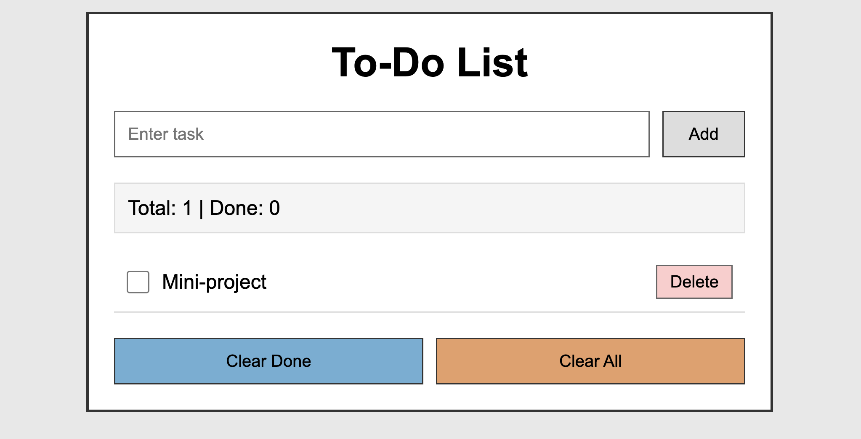

CONCLUSION

The To-Do List project successfully demonstrates how HTML, CSS, and JavaScript can be combined to create a functional task management application. The project meets all requirements by allowing users to add tasks, mark tasks as completed with a checkbox, delete individual tasks, and clear completed or all tasks at once. The application automatically tracks the total number of tasks and completed tasks, providing real-time updates to the user.

